General about DVD

DVD is the new generation of optical disc storage technology. That can hold much more data than CDs. It has replaced laserdisc, is well on the way to replacing videotape and video game cartridges, and could eventually replace audio CD and CD-ROM. In 2003, six years after introduction, there were over 250 million DVD playback devices worldwide, counting DVD players, DVD PCs, and DVD game consoles.

DVD is the work of many companies and many people. DVD evolved from CD and related technologies. Some of the early proposals for "high-density CD" were made in 1993, and these efforts gradually coalesced into two competing proposed formats. The MMCD (multimedia CD) format was backed by Sony, Philips, and others. The SSD (super density disk) format was backed by Toshiba, Matsushita, Time Warner, and others. A group of computer companies led by IBM insisted that the factions agree on a single standard. The combined DVD format was announced in September of 1995.

What do the letters DVD stand for?

All of the following have been proposed as the words behind the letters DVD.
- Delayed , very delayed (referring to the many late releases of DVD formats)
- Diversified , very diversified (referring to the proliferation of recordable formats)
- Digital venereal disease (referring to piracy and copying of DVDs)
- Dead, very dead (from naysayers who predicted DVD would never take off)
- Digital video disc (the original meaning proposed by some of DVD's creators)
- Digital versatile disc (a meaning later proposed by some of DVD's creators)
- Nothing
And the official answer is? "Nothing" The original acronym came from "digital video disc." Some members of the DVD Forum tried to express that DVD goes for "digital versatile disc," but this has never been officially accepted by the DVD Forum as a whole. The DVD Forum decreed in 1999 that DVD, as an international standard, is simply three letters.

It's important to understand the difference between the physical formats (such as DVD-ROM and DVD-R) and the application formats (such as DVD-Video and DVD-Audio). DVD-ROM is the base format that holds data. DVD-Video (often simply called DVD) defines how video programs such as movies are stored on disc and played in a DVD-Video player or a DVD computer.

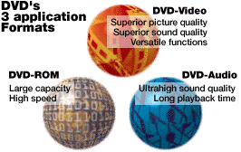
The difference is similar to that between CD-ROM and Audio CD. DVD-ROM includes recordable variations: DVD-R/RW, DVD-RAM, and DVD+R/RW. The application formats include DVD-Video, DVD-Video Recording (DVD-VR), DVD+RW Video Recording (DVD+VR), DVD-Audio Recording (DVD-AR), DVD Stream Recording (DVD-SR), DVD-Audio (DVD-A), and Super Audio CD (SACD). There are also special application formats for game consoles such as Sony PlayStation 2 and Microsoft Xbox.

DVD technical details
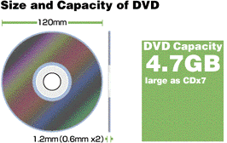
Main specifications of DVD
Disc diameter | : 120mm
Disc thickness | : 1.2mm (0.6mm x2)
Shortest pit length | : 0.4micron meter
Track pitch | : 0.74 micron meter
Sector layout | : CLV
Logic structure | : In accordance with ISO9660 & UDF
Modulation method | : 8/16 modulation
Error correction method | : RS-PC
Laser wavelength | : 650/635nm
Lens (NA) | : 0.6

What are the sizes and capacities of DVD?

Discs come in two physical sizes: 12 cm (4.7 inches) and 8 cm (3.1 inches), both 1.2 mm thick, made of two 0.6mm substrates glued together, same as a CD. A DVD disc can be single-sided or double-sided. Each side can have one or two layers of data. The amount of video a disc can hold depends on how much audio accompanies it and how heavily the video and audio are compressed.
It can play 160 hours of audio (or a whopping 295 hours with dual layers) using Dolby Digital 64 kbps compression of monophonic audio, which is perfect for audio books.
Almost all DVD-Video and DVD-ROM discs use the UDF bridge system file format.
A DVD with the same thickness as a CD, that is, 1.2mm, isn't suitable for error-free reading of high-density data. It's too thick. But adoption of a thin disk makes it difficult to achieve CD compatibility. The solution: the DVD consists of two discs, each 0.6mm thick, bonded back to back to achieve strength and the same 1.2mm thickness as a CD. Also, compared with a single 1.2mm-thick disc, the DVD configuration in which two discs are bonded is less prone to warping due to heat or humidity.
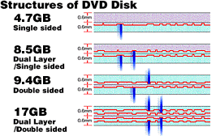

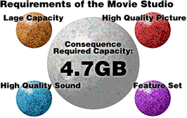

Capacities of DVD:

For reference, a CD-ROM holds about 650 megabytes, which is 0.64 gigabytes or 0.68 billion bytes.
SS (single-sided)
DS (double-sided)
SL (single-layer)
DL (dual-layer)
ML (mixed-layer) (single layer on one side, dual layer on the other side)
GB (Giga Bytes (2^30))
BB (billions of bytes (10^9))

DVD-5 (12 cm, SS/SL) | 4.37 GB (4.70 BB) of data, over 2 hours of video
DVD-9 (12 cm, SS/DL) | 7.95 GB (8.54 BB), about 4 hours high quality
DVD-10 (12 cm, DS/SL) | 8.74 GB (9.40 BB), about 4.5 hours
DVD-14 (12 cm, DS/ML) | 12.32 GB (13.24 BB), about 6.5 hours
DVD-18 (12 cm, DS/DL) | 15.90 GB (17.08 BB), over 8 hours
DVD-1 (8 cm, SS/SL) | 1.36 GB (1.46 BB), about half an hour
DVD-2 (8 cm, SS/DL) | 2.47 GB (2.66 BB), about 1.3 hours
DVD-3 (8 cm, DS/SL) | 2.72 GB (2.92 BB), about 1.4 hours
DVD-4 (8 cm, DS/DL) | 4.95 GB (5.32 BB), about 2.5 hours
DVD-R 1.0 (12 cm, SS/SL) | 3.68 GB (3.95 BB)
DVD-R 2.0 (12 cm, SS/SL) | 4.37 GB (4.70 BB)
DVD-R 2.0 (12 cm, DS/SL) | 8.75 GB (9.40 BB)
DVD-RW 2.0 (12 cm, SS/SL) | 4.37 GB (4.70 BB)
DVD-RW 2.0 (12 cm, DS/SL) | 8.75 GB (9.40 BB)
DVD+R 2.0 (12 cm, SS/SL) | 4.37 GB (4.70 BB)
DVD+R 2.0 (12 cm, DS/SL) | 8.75 GB (9.40 BB)
DVD+RW 2.0 (12 cm, SS/SL) | 4.37 GB (4.70 BB)
DVD+RW 2.0 (12 cm, DS/SL) | 8.75 GB (9.40 BB)
DVD-RAM 1.0 (12 cm, SS/SL) | 2.40 GB (2.58 BB)
DVD-RAM 1.0 (12 cm, DS/SL) | 4.80 GB (5.16 BB)
DVD-RAM 2.0 (12 cm, SS/SL) | 4.37 GB (4.70 BB)
DVD-RAM 2.0 (12 cm, DS/SL) | 8.75 GB (9.40 BB)
DVD-RAM 2.0 (8 cm, SS/SL) | 1.36 GB (1.46 BB)
DVD-RAM 2.0 (8 cm, DS/SL) | 2.47 GB (2.65 BB)
CD-ROM (12 cm, SS/SL) | 0.635 GB (0.650 BB) (650 MB) 15 minutes video
CD-ROM (8 cm, SS/SL) | 0.180 GB (0.194 BB) (184 MB)
DDCD-ROM (12 cm, SS/SL) | 1.270 GB (1.364 BB)
DDCD-ROM (8 cm, SS/SL) | 0.360 GB (0.387 BB)

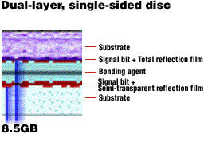

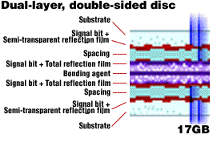

DVD-R

DVD-R (which is pronounced "dash R" not "minus R") uses organic dye technology, like CD-R, and is compatible with most DVD drives and players. First-generation capacity was 3.95 billion bytes, later extended to 4.7 billion bytes. In early 2000 the format was split into an "authoring" version and a "general" version. The general version, intended for home use, writes with a cheaper 650-nm laser. DVD-R(A) authoring is intended for professional development and uses a 635-nm laser. DVD-R(A) discs are not writable in DVD-R(G) general recorders, and vice-versa, but both kinds of discs are readable in most DVD players and drives.

DVD-RW

DVD-RW (formerly DVD-R/W and also briefly known as DVD-ER) is a phase-change erasable format. DVD-RW is playable in many DVD drives and players. DVD-RW discs can be rewritten about 1,000 times.
Recording time varies from 1 hour to 6 hours, depending on quality. DVD-RW disc prices are around $5-$10 (down from the original $30).

DVD-RAM

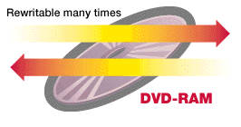
DVD-RAM, with an initial storage capacity of 2.58 billion bytes, later increased to 4.7, uses phase-change dual (PD) technology with some magneto-optic (MO) features mixed in. DVD-RAM is the best suited of the writable DVD formats for use in computers, because it can be used like a large floppy. However, it's not compatible with most drives and players. DVD-RAM discs come with or without cartridges. Discs can only be written while in the cartridge. Cartridge dimensions are 124.6 mm x 135.5 mm x 8.0 mm. DVD-RAM can be rewritten more than 100,000 times, and the discs are expected to last at least 30 years.
DVD-RAM 1.0 blank discs were at about $30 for single-sided and $45 for double-sided.
DVD-RAM version 2.0 Single-sided discs were priced around $25, and double-sided discs were around $30. Disc prices were under $10.

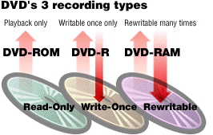

DVD+RW and DVD+R

DVD+RW is an erasable format based on CD-RW technology. It became available in late 2001.
DVD+R is a write-once variation of DVD+RW, which appeared in mid 2002. It's a dye-based medium, like DVD-R, so it has similar compatibility as DVD-R.
In 2003 DVD+R discs cost around $2 to $6 and DVD+RW discs cost around $5 to $10.

Colors DVD

Different colors of recordable CDs and DVDs come from the combination of the reflective metal layer (gold or silver) and the dye used in the recording layer (cyanine [blue], phthalocyanine [clear], azo [dark blue], formazan [green], etc.).

How long do DVDs last?

Pressed discs (the kind that movies come on) lasts from 50 to 300 years.
Dye-based DVD-R and DVD+R discs is anywhere from 20 to 250 years, about as long as CD-R discs.
The phase-change erasable formats (DVD-RAM, DVD-RW, and DVD+RW) have an expected lifetime of 25 to 100 years.

What are the features and speeds of DVD-ROM drives?

A 1x DVD-ROM drive provides a data transfer rate of 1.321 MB/s (11.08*10^6/8/2^20). 1x CD-ROM data transfer rate is 150 KB/s, or 0.146 MB/s. DVD physical spin rate is about 3 times faster than CD. DVD-ROM drives are available in 1x, 2x, 4x, 4.8x, 5x, 6x, 8x, 10x, and 16x speeds.

DVD drive speed | Data rate | Equivalent CD rate | CD reading speed
1x | 11.08 Mbps (1.32 MB/s) | 9x | 8x-18x
2x | 22.16 Mbps (2.64 MB/s) | 18x | 20x-24x
4x | 44.32 Mbps (5.28 MB/s) | 36x | 24x-32x
5x | 55.40 Mbps (6.60 MB/s) | 45x | 24x-32x
6x | 66.48 Mbps (7.93 MB/s) | 54x | 24x-32x
8x | 88.64 Mbps (10.57 MB/s) | 72x | 32x-40x
10x | 110.80 Mbps (13.21 MB/s) | 90x | 32x-40x
16x | 177.28 Mbps (21.13 MB/s) | 144x | 32x-40x

The bigger the cache (memory buffer) in a DVD-ROM drive, the faster it can supply data to the computer. This is useful primarily for data, not video. It may reduce or eliminate the pause during layer changes, but has no effect on video quality.

Compatibility problems with recordable DVD formats

Yes. None of the writable formats are fully compatible with each other or even with existing drives and players. In other words, a DVD+R/RW drive can't write a DVD-R or DVD-RW disc, and vice versa (unless it's a combo drive that writes both formats). As time goes by the different formats are becoming more compatible and more intermixed. A player with the DVD Multi is guaranteed to read DVD-R, DVD-RW, and DVD-RAM discs, and a DVD Multi recorder can record using all three formats. Some new "super combo" drives can record in both plus and dash format, and a few "super multi" drives can record all 5 disc types (DVD-R, DVD-RW, DVD+R, DVD+RW, and DVD-RAM).

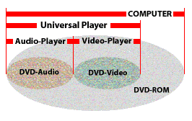

What are .IFO, .VOB, and .AOB files? How can I play them?

.IFO files contain menus and other information about the video and audio. The .BUP files are backup copies of the .IFO files. The .VOB files (for DVD-Video) and .AOB files (for DVD-Audio) are MPEG-2 program streams with additional packets containing navigation and search information.
Since a .VOB file is just a specialized MPEG-2 file, most MPEG-2 decoders and players can play them. You may need to change the extension from .VOB to .MPG. The best way to play a .VOB file is to use a DVD player application to play the entire volume (or to open the VIDEO_TS.IFO file), since this will make sure all the DVD-Video features are used properly.
Many DVDs are encrypted, which means the .VOB files won't play when copied to your hard drive.
If you try to copy the .IFO and .VOB files to a recordable DVD it may not play.

What are "regional codes," "country codes," or "zone locks"?

To control the home release of movies in different countries they required that the DVD standard include codes to prevent playback of certain discs in certain geographical regions. Each player is given a code for the region in which it's sold. The player will refuse to play discs that are not coded for its region. This means that a disc bought in one country may not play on a player bought in another country. Technically there is no such thing as a region zero disc or a region zero player. There is such thing as an all-region disc. There are also all-region players. There six regional codes from 1 up to 6.
Regional codes are also applied to game consoles such as PlayStation 2 and Xbox.
Here a noticeable matter is that each DVD-ROM or Writers have a chipped regional protection system. That the regional codes can be changed only for 5 times and the last one (the 5th one) will be selected the default regional code.

Care for DVDs

Scratches may cause minor data errors that are easily corrected. That is, data is stored on DVDs using powerful error correction techniques that can recover from even large scratches with no loss of data. But DVD error correction is at least ten times better than CD-ROM error correction and more than makes up for the density increase. Major scratches may cause uncorrectable errors that will produce an I/O error on a computer or show up as a momentary glitch in DVD-Video picture.
Since DVDs are read by a laser, they are resistant to fingerprints, dust, smudges, and scratches. However, surface contaminants and scratches can cause data errors. On a video player, the effect of data errors ranges from minor video artifacts to frame skipping to complete unplayability.
Your player can't be harmed by a scratched or dirty disc unless globs of nasty substances on it actually hit the lens. It doesn't hurt to leave the disc in the player, even if it's paused and still spinning, but leaving it running unattended for days on end might not be a good idea.
In general, there's no need to clean the lens on your player, since the air moved by the rotating disc keeps it clean.

Care and feeding of DVDs

Handle only at the hub or outer edge. Don't touch the shiny surface with your popcorn-greasy fingers.
Keep discs away from radiators, heaters, hot equipment surfaces, direct sunlight (near a window or in a car during hot weather), pets, small children, and other destructive forces. The DVD specification recommends that discs be stored at a temperature between -20 to 50 °C (-4 to 122 °F) with less than 15 °C (27 °F) variation per hour, at relative humidity of 5 to 90 percent. Magnetic fields have no effect on DVDs, so it's ok to leave them sitting on your speakers.
Coloring the outside edge of a DVD with a green marker (or any other color) makes no difference in video or audio quality.

Other Future and latest technologies

Advanced Optical Disc (AOD)

The DVD Forum's next-generation DVD, is called Advanced Optical Disc (AOD) or DVD2. AOD is a modification of the existing DVD physical format to enable about 15 GB per layer using a blue-ultraviolet readout laser. The same 0.6-mm data depth is used. AOD is designed to improve data capacity while theoretically being able to use existing replication equipment. It is primarily supported by Toshiba and NEC.

Blu-ray Disc (BD)

Blu-ray is a new high-density physical format that will hold 23 to 27 GB per layer using a blue-ultraviolet laser and a 0.1-mm data depth. Because of the 0.1-mm cover layer it will require significant changes to production equipment. Blu-ray is initially intended for home recording, professional recording, and data recording. Mass-market distribution of pre-recorded movies will come later, after the read-only format, called BD-ROM, is developed and the details of video, audio, interactivity, and copy protection are hammered out. Blue-ray backers are LG, Panasonic, Philips, Pioneer, Hitachi, Mitsubishi, Samsung, Sharp, Sony, and Thomson. Sony released the first BD recorder in Japan in April 2003.
Technical details: up to 27 GB per layer using 0.1-mm recording depth (to reduce aberration from disc tilt), 405-nm blue-violet semiconductor with 0.85 NA (numerical aperture) lens design to provide 0.32 µm track pitch (half that of DVD) and as small as 0.138 µm pit length. Variations include 23.3 GB capacity with 0.160-µm minimum pit length and 25 GB capacity with 0.149-µm minimum pit length. The physical discs uses phase-change groove recording on a 12-cm diameter, 1.2-mm thick disc, similar to DVD-RW and DVD+RW. 36 Mbps data transfer rate. Recording capacity on a single layer is about 2 hours of HD video (at 28 Mbps) or about 10 hours of standard-definition video (at 4.5 Mbps) . Cartridge size is 129 x 131 x 7 mm. Plans are to produce dual-layer recordable discs, holding about 50 GB per side, but such discs will take a few additional years to appear.

What is the difference between CD and DVD?

As we know that a CD or DVD surface is made of Pits and Lands.

In CDs the space between two pits are 1.6 µm and the pits size is a minimum of 0.83 µm.

And in DVDs the space between two pits are 0.74 µm and the pits size is a minimum of 0.4 µm, so it si compressed or even more compact, that is why it stores more than a CD disk.

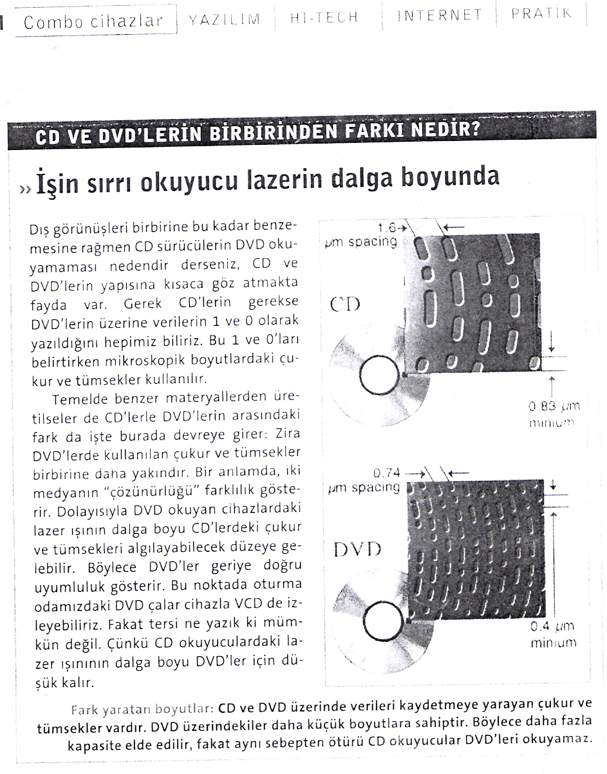

City square or market, place of assembly, place for conducting official business (in ancient Rome); court; place where discussions are held; message board on the Internet focused on a particular subject (Computers)

